|  |  |  |  |  |  |  |
| --- | --- | --- | --- | --- | --- | --- |
|  | | | **School of Creative and Digital Industries** | | | |
| **Module Title:** | Project | | | **Module Code:** | CO699 | |
| **Assignment No/Title:** | CW1 |  | | **Assessment Weighting:** | CW1 | 10% |
| CW2 |  | | CW2 | 20% |
|
| **Submission Date:** | CW1 | 10/11/22 | | **Feedback Date:** | + 3 Weeks | |
| CW2 | 12/01/23 | |
|
| **M****odule Tutor:** | Justin Luker | | | **Degree:** | Degree | |
| **Student ID:** | **21905318** | | | **Student Name:** | **Amir Mohamed** | |
| **1st Supervisor:** | **Rafid Al-Khannak** | | | **2nd Supervisor:** | **Richard Bacon** | |
| **Course:** | BSc. (Hons) Software Engineering | | | | | |
| **Word Count:** |  | | | | | |

**Project Title: -**

**A Digital assistant developed using C++ language that can contain all your Daily Tasks, Routines, Appointments, Checklists, Financial Budgeting to assist users with their daily struggles of organization and increase their work rate by ensuring an organized app that can be used like an assistant for the user’s organizational needs.**

Contents

Project Title 3

Introduction 3

Background 4

Rationale 5

Ethical Considerations 6

Aim 6

Objectives 7

Risks 8

Literature Survey 9

Methodology 10

Requirements 11

Design 13

Glossary 17

References 17

Bibliography 19

Appendix A: Project Plan 19

Appendix B: Ethics Checklist 20

Other Appendixes (C, D, E etc. as required) 22

# Project Title

**A Digital assistant developed using C# language and tools such as visual studio that can contain all your Daily Tasks, Routines, Appointments, Checklists, Financial Budgeting to assist users with their daily struggles of organization and increase their work rate by ensuring an organized app that can be used like an assistant for the user’s organizational needs.**

# Introduction

The general problem some people come across is staying organized. Keeping track of what needs to be done can be very difficult specially when there is multiple deadlines or tasks to complete. After some research into applications or tools that can assist users by providing organizational features and I have come across a blog written by Ilic, Aleksandar (2016) “Problems keeping up? 10 apps to make you highly organized”. It mentions 10 different apps that have different purposes and features the user can benefit off. The main two apps that caught my attention was app 3 “Toggl - A time tracking app that helps time management” and app 7 “Wunderlist -A to do list app that has additional features to comment/remind users of a task”. Those two apps had a similar concept of my idea but was split into different apps. The main purpose of my app idea is to provide a simple and reliable app that provides users with an organized platform to assist them with their day-to-day tasks. The features my idea will provide are based on apps users may need due to the features they provide. The features included in my idea would be the ability to time manage using a calendar/planner, create reminders for task or deadlines, create a to do list for house chores/shopping or checklist for a routine you want to make/keep, in addition to financial budgeting. These are the essential day to day apps users use that can help their organization significantly specially if they are in one application. An article by Herbert, J. (2021) “5 surprising benefits of being organized” It mentions 5 different points of how having an organized lifestyle can help improve your work rate and produce better outcomes due to less stress. The reason I want to develop this app is because I couldn’t find apps that was sufficient to help with organization of tasks/deadlines and other. My main goal in this project is to develop a prototype with functioning features to be able to test. The most challenging part about this project will be the coding of the application features because I don’t have much experience in application coding to develop apps. My current skills and knowledge of application coding will improve throughout the development of this app in addition to researching features and inspecting their code. An article on a website called Fireart Studio (2022) “Topmost Popular Programming Languages for Mobile App Development” it has many different programming languages with pros and cons for each, in addition to a small summary of what it does and best used for. It also mentions the two types of applications (Native apps, Hybrid apps). My plan from this project when fully developed is to make it functional cross platform in addition to accessible to any smart mobile device. The article mentioned many different programming languages that could be used for app development and the plan for this project is to develop the prototype for IOS to start and later adjust it for the other devices after testing the prototype.

# Background

My idea came from my day-to-day life tasks and that I struggled to find apps to help me organize. I have always wanted an app that was like an assistant that would help the consumer have a much more organized work to life balance. I struggled to find the correct balance between working, studying and entertainment such as social media etc... My struggle was that I will spend too much time doing one thing that I forget I have other important deadlines or tasks to complete and end up having way too little time to complete the task which will cause problems or not as good of quality due to lack of time spent on the task. That is when I started looking for apps that would help users on multiple day to day life tasks and improve the life balance to ensure best productivity of the consumer. I discovered a couple apps that have similar features to my idea such as Reminder app, Calendar, and others. The main issue was that they were separate applications that served different purposes and wasn’t very interactive with the user and I believe is limited on its features. My main interest in my idea are the features I want to be included during the development of my idea. I believe my ideas aren’t unique but are an improvement on current apps that have been developed but aren’t as interactive with the user or require additional features to provide a better user experience. These features are very interesting to me because I think it will be a challenge to code them and learn to implement them with a good user interface. This project will be developed without a team or a need for a budget, however there will be a couple technical challenges, but my main technical challenge will be trying to keep up with new markets and ensuring the app is up to date with the updated tools. The target market for my application is not limited because I want to create this app to provide a platform with organizing features to provide the consumer with an app to organize their tasks and schedule to allow for the user’s best time management. This software idea will be interesting to the consumers because it provides a platform with multiple day to day features that would help the consumer with multiple management features to simplify the users stress of organization. As mentioned, there are some similar apps such as the reminders, calendar, budgeting, and other apps. I had completed some first-hand research using the Reminder, Calendar and a budgeting tool called “EMMA” and I found them useful, but I believe that an app that has the merged features of the researched apps would provide a much better user experience in addition to improving the apps’ purpose and usage by consumers. An article on a website called “Household Money Saving” by Money Saver Pete (10/10/2022) includes a full review on the Emma budgeting app which I have used to confirm some of my issues that I had with the app. The main research I gathered so far is from personally using the applications and noting down the issues I have had with them. On top of that I have made some other research on some general assistant apps and have come across an article on a website called “the muse” written by K. Smith (19/06/2020) The title is “8 Free apps that double as personal assistants” and it mentions 8 different apps that may help the user for different purposes but have limited features that would limit the user’s usage of the app. The main issues I have come across is that some apps aren’t accessible on IOS or just designed for android phones or the other way. I want my software idea to be available for IOS and android to maximize the users in addition to being able to have access to all the features that help the consumer with their day-to-day tasks.

# Rationale

The aim or this project is to help users’ organization problems of their day-to-day tasks. The purpose of this project is to provide a platform where users can store their important tasks/deadlines or simple house chores that need to be done. In addition to assisting the users with their financial budgeting. The app will provide interactive features that simplify the use of the app and helps the users by allowing them to organize their important tasks. The client required an application that would assist them with their daily tasks due to struggles of keeping track of important tasks or deadlines. My final assessment for this course is to develop a software idea into a partially working prototype. The assessment was to show the entire progress of developing this idea into a prototype. Developing this software idea into a prototype will demonstrate my skills of application development. This may be challenging because it will be the first app I will be developing, and my skills and knowledge of app development will require a lot of research in addition to practice to be able to develop a functioning prototype. My work industry requirements include the development of software and coding in different languages that includes documenting the progress of a project in development. After some research I have found a website that provides job description information called “Resources for Employers” it mentions the requirements for a software engineer and this application development module has similar steps regarding the development and the documentation of the process. I believe this app idea is potentially very useful for many users. The reason I believe that is because I haven’t found a similar app with the same or similar concept of assisting the users with their daily organizational project. In the background section I mentioned a couple apps that have similar features but was in separate apps, my app idea isn’t unique but a merge and improvement on features of apps that have been created but lacked to be maintained by their developers to the current standards. Apps such as the Reminders, Calendar, Notes have been developed but are separate apps that in my opinion would be much better if created into one app that has some additional features that would maximize the users experience and increase the targeted clients. When trying to research apps like my idea it mostly directs you to an assistant device such as google or Alexa which are good for home use but not very useful when not in proximity of the device. The app I am trying to develop would be installed on the personal smart phones which is mostly with the user. The main challenge would be coding the budgeting feature into the app because the feature needs to be simple but also secure for users. My current knowledge and coding skills are very low to be able to code the feature into a functioning prototype. This part will require a lot of additional research to successfully complete it. I have found a website by Kalinin, K (2022) “How to create a personal finance app for budget planning” it has a section “top 5 budget apps for personal finances” where it includes 5 different budgeting apps that are available to download and use once subscribed to their services. My plan is to use some of them and not the most important features and the main issues form the apps to try and find a better solution for my feature development. This software idea could potentially be used by many due to the simplicity and useful features that are coded to provide day to day assistance to the users.

# Ethical Considerations

When talking about ethical considerations this project is unlikely to cause any harm to users ethically or morally speaking. Taking the project assignment into consideration, the project will be a prototype with functioning features that won’t require any personal data to be included which will eliminate the risk of data breach or any other ethical considerations however we will discuss some of the ethical considerations. The main one to talk about is the data breach. Securing the data inputted by the user will be essential to the final release of this project but the prototype will focus on ensuring that the features function. Feedback gathered from the prototype will help improve the features and find out any bugs that may have happened during the development in addition to simplifying the use of the application. The application will require the users to login to gain access to their app. This is to prevent anyone being able to access other users’ data, in addition to that I plan to add a way of improving security with maybe using two factor authentication or other security methods.

# Aim

The purpose of this software idea is to demonstrate my skills and knowledge that I acquired during the modules of my course and its required me to develop a functioning prototype of a client or an app idea. During this process I get to develop an application idea that may potentially be very useful to many people if developed correctly. This project will be testing my coding and implementing of application features to develop an application, in addition to documenting the progress of developing the app. The project aim is to provide a functioning prototype of my application idea that can be tested to receive feedback. This project consists of 4 main features that would be very useful to users on a day-to-day basis. This idea will provide a platform for users to organize their day-to-day task/routines in addition to financial budgeting aid. The main four would be Calendar, Reminders, Notes, Budgeting. These features would be useful for users to create an organized system for their day-to-day organizational struggles. (1st) Calendar feature would provide an overview of a calendar in addition to any schedules tasks the user has set in the coming days, which will also provide interactive features such as reminding the user a day before the scheduled task. (2nd) The notes feature would provide users with a page to create notes that can be written into checklists or shopping lists etc... The created notes for example a shopping lists can be saved and attached to either a calendar to schedule a day to do shopping or a reminder.(3rd) The reminders feature allows the user to set a reminder and schedule it in a much more specific time or way such as time of the day, dedicate duration, priority of task, and can have an attached list from notes that can consist of a quick note or checklist. Reminder’s feature can be used to create a daily checklist reminder for example to take your medication if daily medication is needed or a completely different purpose to try maintaining a daily routine. (4th) The last feature would be financial budgeting, which will allow the user to manage their finances and have an overview of their financial status. This app idea could be very useful because it could assist users with their day-to-day tasks, in addition to provide an organizational system for users to manage their tasks to ensure their productivity is maximized. I believe this app will solve many issues and have a much better impact to daily organization for people.

# Objectives

**Development Objective**

1. A) Complete the app screens by creating a template. Creating the template and use template to create multiple screens for the different requirements to provide a working user interface to the working screens. Implement the different screens and assign them their requirement that will be implemented at a later stage.

(Provides a starting base for the upcoming parts)

B) Set up DATABASE/Data Storage for the data that has been inputted by the user to create or login their accounts.

After this objective has been completed the app should have a working interface with multiple screens that are linked by a navigation bar.

**Implementing the requirements**

1. Complete the coding of each feature and implement them into the correct screens that was created for each requirement.
2. Calendar Screen/ coded Features and implement into assigned screen
3. Reminder Screen/ coded Features and implement into assigned screen
4. Notes Screen/ coded Features and implement into assigned screen
5. Budgeting Screen/ coded Features and implement into assigned screen

At this point of the development, there should be some functionality of switching between the screens using the navigation bar in addition to the different features (A, B, C, D) of the app being functional.

**Final check of requirement objectives**

1. A) Completed the coding of requirements, Final Checks of the implemented features.

B) Adjusted the interface and features to work in sync

After 3rd objective has been completed, the prototype app should be functional

**Implementing the Login/Create features**

1. A) Complete the login/ create account interface and link to data base.

B) Create the apps first prototype and test out the features.

# Risks

|  |  |  |  |  |  |  |
| --- | --- | --- | --- | --- | --- | --- |
| **Risk** | **Description of risk** | **Probability of risk occurring** | **Reason of risk potentially happening** | **Impact it will cause** | **Actions to avoid risk** | **Impact on entire project** |
| **Coding Problems** | Problems with coding the features required | Medium - high | My coding of features may cause issues when coding the features | Major delays in the project + not having a functioning prototype. | Researching into the required features + Practice coding | Failure of project / assignment.  Delay to prototype outcome |
| **Implementation problem** | Problems with implementing the feature into the app | Medium - high | My coding experience may cause the delay | Major delays in the project + not having a functioning prototype. | Researching into the required features + Practice coding | Failure of project / assignment or  Delay to prototype outcome |
| **Aggressive / missing deadlines** | Too Little time to complete an objective for multiple objectives | Low | Not enough time dedicated to project | Causes objective deadlines to be missed | Dedicated enough time for each objective to be completed & checked | Failure of project / assignment or  Delay to prototype outcome |
| **Low Productivity (low project progression)** | Working slow / low project progression | Low | Not being able to understand how to approach the objective/ Slow progress when working on project | Major delay to the project outcome | Each objective has a deadline to be achieved for and each objective has enough time dedicated for its completion | Failure of project / assignment or  Delay to prototype outcome |
| **Technical Issues** | Issues occurring with software or hardware | Medium | Technical issues may occur at any time of the development | Major delay to the project outcome | I have done some research on troubleshooting while development | Failure of project / assignment or Delay to prototype outcome |

# Literature Survey

Our current skills and knowledge of developing application software are basic and will develop with the progress of this software development. This may cause the project to be delayed throughout their development cycle but allow me to gain experience in developing software. According to an article written by Firenze, A. (2022) “14 essential App Development teams skills you must have” mentions the essential skills that an application developer requires to develop software applications. While searching for apps with similar features to my idea, I came across an article written by Ching, C. (2021) “How to make an app in 2021 from start to finish” provides a stepped guide on how to develop an application and the necessary steps to take to ensure your project will succeed. The research has allowed me to verify certain features are very useful to have into my project. The first feature included into my project is a calendar, an article by Stevens, G. (2022) “6 best calendar app features to help you manage your business better” it talks about all the useful features a calendar has that is able to help users with a variety of features that can assist one or a business. The second feature is to create reminders that can be customized to the user’s needs. The third feature is creating notes that are customizable to the user’s needs such as creating a checklist for shopping, or one to take prescribed medication regularly. The last feature would be budgeting, my research into the development of my software idea allowed me to find an article written by Shibli, A. (2022) “15 best organization apps for life & work in 2022” It mostly includes calendar and note applications that are supposed to help the user be more organized with their tasks. All the apps have similar features but was designed differently and have a different subscription fee. The main issue I have found was that the apps that help you stay organized with your day-to-day tasks are separate applications and each may possibly have a different subscription fee. Another day-to-day app users may require is financial budgeting. A review by Money Saver Pete (2022) “Emma App review” provided a clear understanding of the benefits of financial budgeting, in addition to budgeting being used by many people and potentially most of our future users. As many other apps EMMA provides more features the higher subscription you sign up for. My project is meant to be a solution to multiple problems, Firstly the issue of having multiple apps which sometimes causes disorganization. Secondly it would provide one app with multiple features that will be useful to the user’s organization troubles and mostly will allow the users to save money instead of subscribing to multiple app subscriptions. The research completed helped verify that the features will be useful to the users by providing them an organized system that is easy to use. The project plan and objectives allow the project to be divided into sections when being developed. This allows the development of the prototype to be split into sections that will function as intended if the objectives have been completed no matter what order they were coded in. A website name Altexsoft released a very informative article in 2019, “Best practices and methodologies” Contains detailed information on what project management is, in addition to how many different methods of developing with some descriptions and diagrams or the approach. There are many options to choose from but the most common ones is the waterfall model or the agile model.

# Methodology

In this section I will be discussing the chosen method of developing the project idea, in addition to reference any research completed towards this project and describe my decisions. A website name Altexsoft released a very informative article (2019), “Best practices and methodologies” It contains an explanation on how the common methods such as Waterwall and agile method function and how they are used in the development process. I have also found an article on a website called “Wrike” (2021) “*The benefits & Advantages of Agile*” which contains the benefits of the agile method in addition to a comparison between other similar methods. This project will be developed using the agile approach. This is due the advantages agile methodologies provide in addition to the flexibility agile provides in term of adding additional requirements throughout the process or sudden unknown changes. This project will develop my first app prototype and my knowledge and skills of application development is very limited and requires a lot of research and coding assistance. My plan is to use an application development tool to assist me with the coding of the prototype and features. I believe staying on track with the scheduled project plan/ objectives is essential for the project outcome. Since the project management method has been chosen to be the agile method, we proceed by reminding ourselves with the project plan and objectives.

The projects plan consists of more detailed planned step by step guide to complete the prototype, where the objectives are intended as a project progression goals that provides an overview of how the project has been progressing. I have found a website by Welch, S. (2021) “the 5 best C++ IDES” which provides a bunch of tools that have pre-set IDES to help users productivity and explains what IDE is and why it’s useful. I have also found a website by Cardello, J. (2023) “14 best prototyping tools for UI/UX Designers”, it lists 14 different tools that could be used to design a user interface and potentially assist on coding the interface to have a good base to start the project on. The project plan has been split into multiple sections for each stage to split the workload and provide a better time managed plan to reduce delay risks. It also allows the development of the project to be completed in sections to complete an objective and see progression of the project. Each objective will have a stage to go over the completed work to ensure any unseen issues and double check the written code for any spell errors. My plan on how to implement the method into my project was to try to develop each objective and approach them individually using the agile method. This is because in my project plan, I have split each objective to have multiple tasks to ensure the objective was given enough time for completion. I will be using visual studio code to try to prototype my project. To assist me with coding I will be using some software development tools.

# Requirements

In this section I will be discussing the requirements regarding this project. This project idea wasn’t requested by a client, this project idea came from experiencing the issue and wanting to find a solution for it. The issue was that I struggled to find the correct organizational system to keep my balance between studying, work, and socializing. In addition to that I had couple people with similar issues throughout their day-to-day lifestyles. I was able to have a short interview with potential users that helped me set a couple of set requirements the project needs to include. The interviews were short but helped understand the issue better and help improve on the requirements. Each feature helps the users stay organized,

* Calendar will need to be able to schedule some event or task with some customization of how and when to notify.
* Reminders will need the ability to schedule a task in a much more specific way such as time, days etc...
* Notes need to allow the ability to write notes in addition to customize the note into a checklist to use for a daily routine checklist
* Budgeting needs to allow users to manage their finances using tools provided.

The requirements aren’t complicated due to the apps purpose, and I will try to keep the application simple for users to use. The discussion about the security of the app and accessibility was very informative, It showed that some people don’t require lot of security to keep track of their tasks. This made the 4 digit pin a customizable feature for the people that want to enable it. The accessibility conversation was different because the initial plan is to allow access to al smart devices but at final release this includes to any other smart devices such as smart watches.

**Functional: -**

1. Calendar: Schedule events + have an attached note from notes feature.
2. Reminders: create more specified reminder (specific time/Day) in addition to creating a daily reminder of a checklist using notes attachments.
3. Notes: Allows to write notes + create checklists, attachable to reminders and calendar.
4. Budgeting: provides the ability and tool to financial management and have an overview of your financial savings.
5. Security: adding login & password with the possibility of additional authentication required for new devices. (Unlocks app with FaceID or a set 4-digit code)

**Non-Functional: -**

* Simple & Fast interface
* Interactive with user

**Questions asked during the short interview:**

1. **What is your main way of staying organized (keeping track of what you need to get done?)?**

1st, Currently I don’t have one I just write down a note of my what I need to do and try to get my work done that way, its very troubling because I miss a lot and I am very unproductive.

2nd, Calendar but its not very interactive with me and lacks the necessary features, tried to look for some other app to help with staying organized but they either cost monthly and are limited on the features.

3rd, I have non and it’s causing me a lot of trouble at work and home, I am constantly late to deadlines and miss important points and my home is a constant mess.

1. **Do you use any app to stay organized?**

1st, I tried to look for an app to help me with organizing but the ones I found they are limited on features and server singular purposes.

2nd, Calendar was supposed to help me, but it hasn’t been working well. I do use a medical app to remind me to take my medication that I need to take daily and some multiple times a day.

3rd, I have tired an app that is supposed to help you maintain a daily routine, it wasn’t much just an app that had a checklist of things you want to do such as walk, shower, brush teeth etc. but it also had subscriptions to unlock further features.

1. **If you pay for subscriptions how much total does it cost, you to try stay organized?**

1st, at one point I had a couple subscriptions to different apps that supposed to help me stay organized and even budgeting apps that ended up costing me 50£ and it still didn’t help my struggles of horrible organization.

2nd, I have a budgeting app that cost 10£ a month to maintain but it is very slow and not very useful. I didn’t try apps to organize my tasks

3rd, I have an app that I can also access on my laptop and see, its very confusing to understand and try to utilize on a daily basis. The app allows you to create a weekly schedule that help you stay productive any maintain a balance between socializing and working.

1. **Do you think an app for daily organization could be useful?**

1st, most definitely, if its dedicated to helping someone keeping track of their necessary task on a daily would be very useful.

2nd, Of course, any app that could help me keep track of my tasks from house chores to university deadlines would be useful

3rd, 100%, keeping track of your daily tasks is essential.

1. **What would you need to help you stay organized in your day-to-day tasks or in general?**

1st, I think there aren’t many things you would need. But a calendar, notes and maybe reminders would be needed to keep track of what needs to be done.

2nd, an app that allows me to write down a task as soon as I get it and it should provide the ability of reminding or adding notes to the reminder.

3rd, An app that help me maintain my task from work deadlines to home chores such as laundry, in addition to financial budgeting.

1. **What is wrong with the current developed apps?**

1st, They are alright but don’t seem to help me stay organized, and some are overpriced for how little they do.

2nd, they are alright but some serves a purpose like mine but won’t help me and owning multiple subscriptions is getting expensive.

3rd, They are good for their designed purpose but they aren’t designed to serve as a day-to-day tool for organization or assistance to the user.

Another discussion with the three people I had a short interview with, and we discussed the security of the app and accessibility. We argued whether a 4-digit pin was required to access the app and if the app would be accessible to other devices that are also smart devices.

# Design

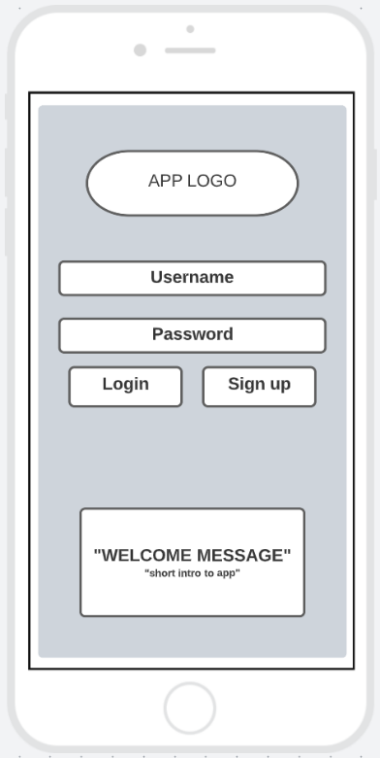In this section I will be displaying the designed wireframes of my project and try to explain the designs. I will try to explain how I plan to implement my method into the project development. I will be using the agile method for each objective separately. This will allow me to focus more on the stage I am currently developing and will show a better progression in addition reduce the risk of delay or low productivity identified in the risk section. The project plan is split into many sections with each having subsections and completing a sections subsection is equivalent to completing a goal set. The objectives are the goals set and will provide a clearer overview of the project progress.

**Login: -**

This is the login screen, comes once to the user when first downloading the app. Allows the user to login if they have an account or sign up for an account.

This is to ensure the users information isn’t public and secured for the users use only. When creating the account the user sets a 4 digit pin, this pin will be used to regain access to the account. This pin will be used at any time users launch their app to provide some sort of additional security to the clients data.

A welcome message with potentially a small app description or introduction.

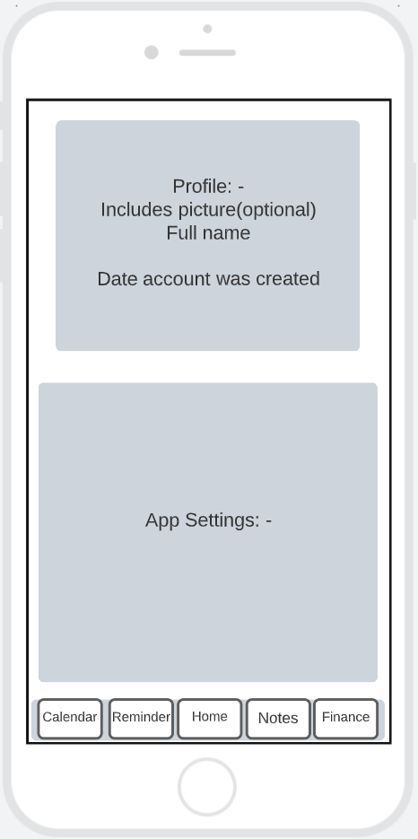**Profile: -**

This would be the profile screen, because the app isn’t based about the person’s profile it doesn’t need much user information apart from name and the email address used to sign up with the option to add a picture.

Here is also where the application settings are. Settings that a user would like to customize themselves. For example, Dark / Light mode is a setting many users may enjoy but not all do.

The purpose of the app is to assist with organization; therefore, the security of this app is based on the individual users. The security settings include: -

Enable/Disable 4-digit pin / Even If disabled. Pin still required for finance screen

Enable/disable FaceID/ TouchID

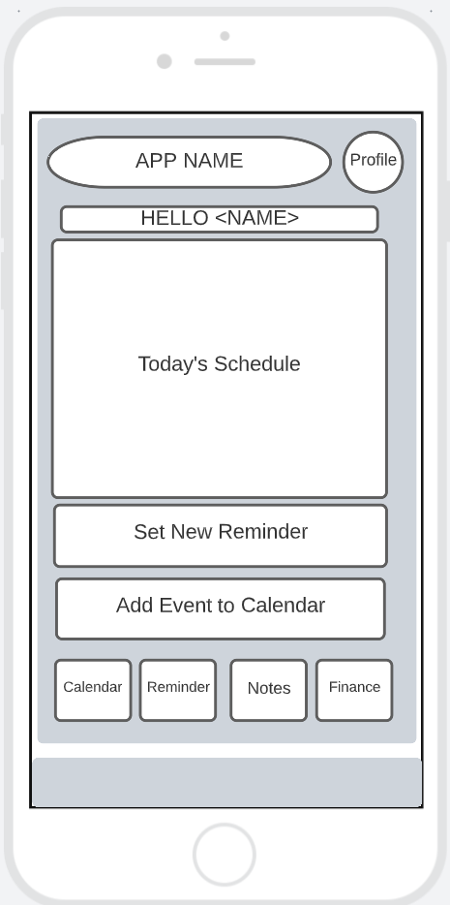**Home Screen: -**

This is the main screen when the app is launched and granted access. Includes the app name and profile access at the top.

The “Today’s Schedule” section is where any planned events or set reminders are found listed from the earlies first to the latest last.

First click on “Today’s Schedule” enlarges the section to cover entire screen and enlarge the schedule board.

“Set New Reminder” & “Add Event to Calendar” Allows users to create a new Reminder or add an event to the calendar.

Provides navigation to other features/screens.

When the schedule board is enlarged or adding to the schedule will make the Gray box at the bottom of the screen turns into a “Return” button.

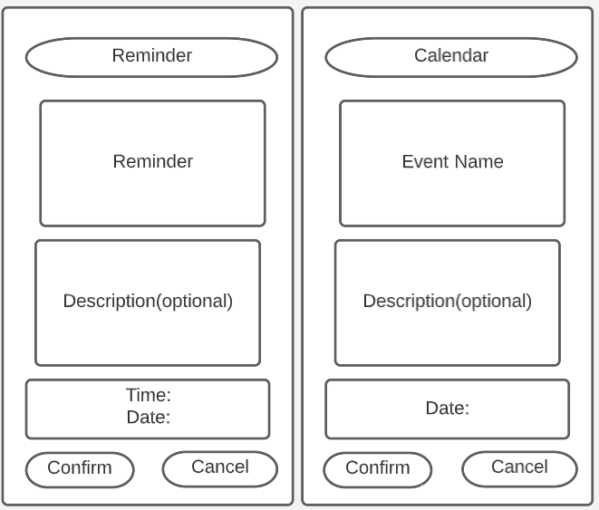

Reminder: shortcut to create a quick reminder

Calendar: shortcut to schedule an event.

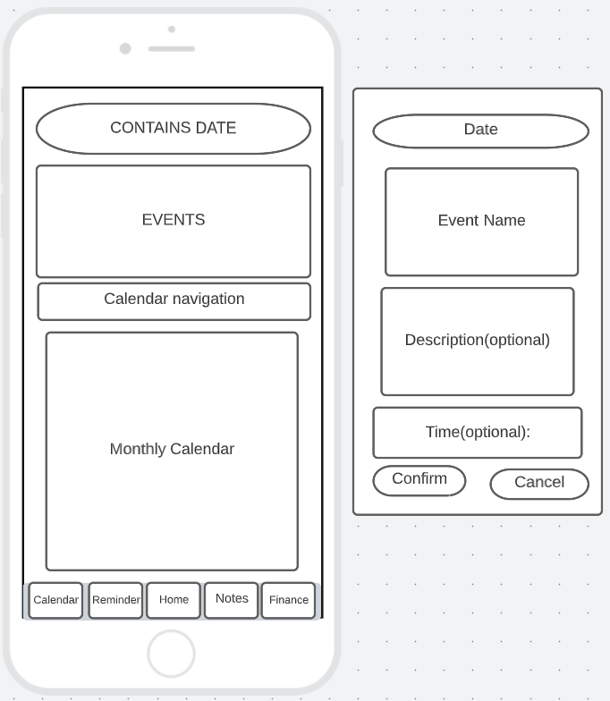Calendar: -

This is the calendar screen.

Events holds the scheduled events and lists them from earliest first to latest last.

Calendar navigation allows users to select the month and potentially year with a simple drop-down menu to change year and arrows to change between months.

Monthly calendar shows the days in the calendar, and it is colour coded from red to show a busy day, yellow/orange medium and green for free day.

When clicking on a day in the monthly calendar it displays the pop up to schedule an event if required.

Navigation bar: to switch between the screens/features available.

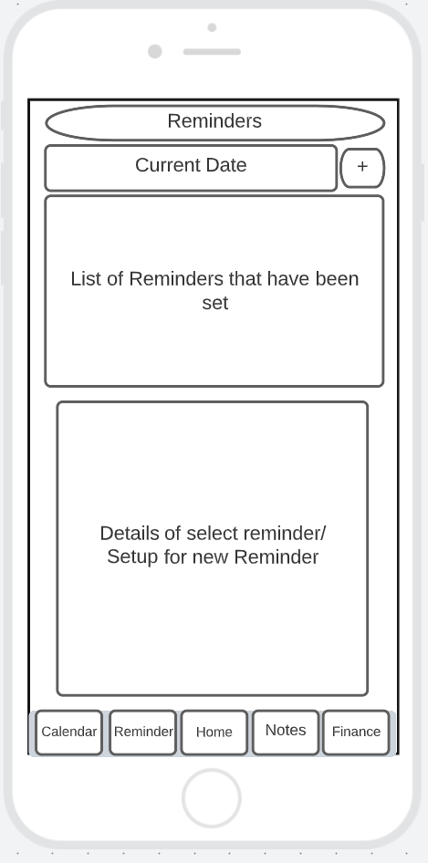Reminders: -

This is the Reminders wireframe. The top provides the current date and next to it the ability to add a new reminder

The list of reminders lists the set-up reminders and lists them earliest first and latest last to keep it organized.

This will show the selected reminders details any description time and name or the reminder. Trying to set up a new reminder will also display the details requested to notify the user.

Navigation bar: to navigate through the app

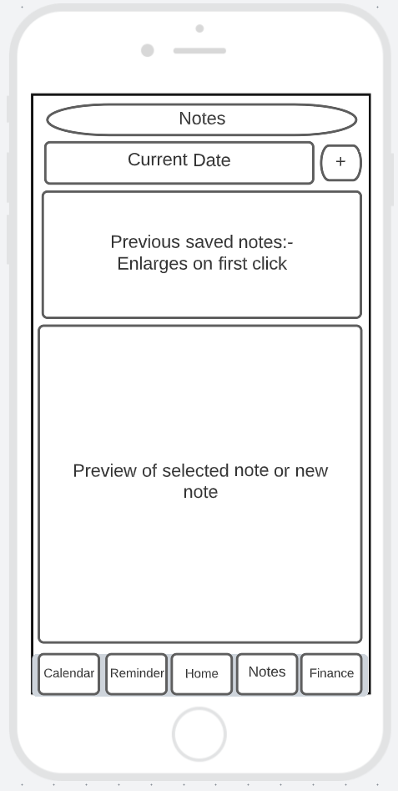

Notes: -

The top is same as most screens containing the screen you’re on and the current date with the option to create a new note.

Saves the notes written by the user and displays the last 3-5 opened. Clicking on it will enlarge it to full screen for better viewing.

Shows a preview of the selected note or opens new note when trying to create a new note. Holding down in the notes box will maximize it and show a minimize button in the corner.

Navigation bar.

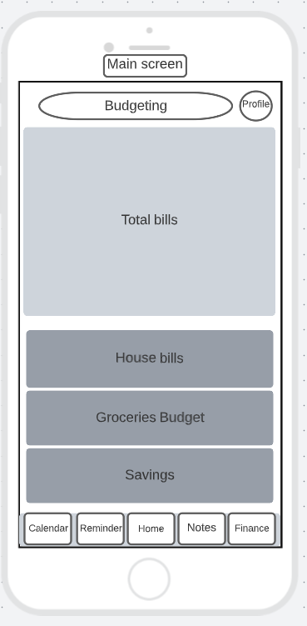

Finance: -

Finance screen is the budgeting feature. The main screen is the first look you will see when clicking on it. It allows users to have an overview of their total income, in addition to overviewing how much they have dedicated to the save spaces.

Dark grey boxes labelled for their individual save space. Shows the total dedicated for their purpose. Clicking on a box will show the entire history for each month.

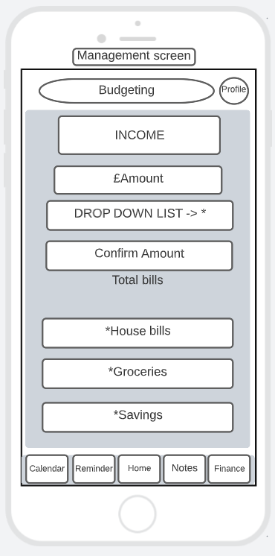The management screen you can access when clicking on total bills which will also show you your previous months.

Allows you to type total income.

Allows you to set an amount of money and dedicate it to a save space* The “drop down list” will allow you to select from your save spaces to save money there. Confirm button to confirm the transaction.

*Save spaces for money management.

# Glossary

Database: - According to an article by Lutkevich, B and Hughes, A (2021) “What is database?” it mentions that Databases are information storage the is easy accessed and managed by a computer used to store information given to it by users as a by-product of a service being provided.

Ethical Consideration: - A website by Bhandari, P. (2022) “Ethical considerations in research” mentions all the reasons why it is important to developing software. To summarize, Ethics is important to ensure the safety of the client’s information. It continues to mention that the (IRB) Institutional Review Board will require a research proposal for the developers to get approval to continue the development of their software.

# References

Introduction: -

Ilic, A. (2016) *Problems keeping up? 10 apps to make you highly organized*, *Lifehack*. Available at: <https://www.lifehack.org/463502/problems-keeping-up-10-apps-to-make-you-highly-organized> (Accessed: December 21, 2022).

Herbert, J. (2021) *5 surprising benefits of being organized - selecthealth.org*, *5 Surprising Benefits of Being Organized*. Available at: <https://selecthealth.org/blog/2021/01/5-surprising-benefits-of-being-organized> (Accessed: December 21, 2022).

IreneIt’s high time to get down to the most popular programming languages for mobile app development. Do these app development languages differ from those…, (Author not found) (2022) *Topmost popular programming languages for mobile app development*, *Fireart Studio*. Available at: <https://fireart.studio/blog/top-most-popular-programming-languages-for-mobile-app-development/> (Accessed: October 28, 2022).

Background: -

Pete, M.S. (2022) *Emma App Review: Money management made easy?*, *Household Money Saving*. Available at: <https://www.householdmoneysaving.com/emma-app-review/> (Accessed: October 29, 2022).

Smith, K. (2020) *8 free personal assistant apps*, *The Muse*. The Muse. Available at: <https://www.themuse.com/advice/8-free-apps-that-double-as-personal-assistants> (Accessed: November 3, 2022).

Rationale :-

Kourmentza, E. (2022) *Software engineer job description*, *Recruiting Resources: How to Recruit and Hire Better*. Available at: <https://resources.workable.com/software-engineer-job-description> (Accessed: November 4, 2022).

Kalinin, K. (2022) *How to create a personal finance app for Budget Planning in 2022*, *Topflight*. Available at: <https://topflightapps.com/ideas/how-to-build-a-budget-app-for-personal-finances/#4> (Accessed: January 7, 2023).

Ethical considerations: -

**Literature Survey: -**

Firenze, A. (2022) *14 Essential App Development Team skills you must have*, *Ascendle*. Available at: <https://ascendle.com/ideas/14-skills-your-app-development-team-must-have/> (Accessed: November 5, 2022).

Ching, C. (2021) *How to make an app in 2021 from start to finish (10 steps)*, *CodeWithChris*. Available at: <https://codewithchris.com/how-to-make-iphone-apps-with-no-programming> (Accessed: November 9, 2022).

Stevens, G. (2022) *6 best calendar app features to help you manage your business better*, *Zoho Blog*. Available at: <https://www.zoho.com/blog/calendar/best-calendar-app-features.html> (Accessed: November 9, 2022).

Shibli, A. (2022) *15 best organization apps for life & work in 2022*, *15 Best Organization Apps for Life & Work in 2022 | Friday.app*. Available at: <https://friday.app/p/organization-apps> (Accessed: November 6, 2022).

Pete, M.S. (2022) *Emma App Review: Money management made easy?*, *Household Money Saving*. Available at: <https://www.householdmoneysaving.com/emma-app-review/> (Accessed: November 5, 2022).

Altexsoft (2019) *Agile Project Management: Best practices and methodologies*, *AltexSoft*. AltexSoft. Available at: <https://www.altexsoft.com/whitepapers/agile-project-management-best-practices-and-methodologies/> (Accessed: January 10, 2023).

**Glossary: -**

Lutkevich, B. and Hughes, A. (2021) *What is a database? definition from searchdatamanagement*, *SearchDataManagement*. TechTarget. Available at: <https://www.techtarget.com/searchdatamanagement/definition/database> (Accessed: November 4, 2022).

Bhandari, P. (2022) *Ethical considerations in research: Types & examples*, *Scribbr*. Available at: <https://www.scribbr.co.uk/research-methods/ethical-considerations/> (Accessed: November 4, 2022).

Methodologies: -

Altexsoft (2019) *Agile Project Management: Best practices and methodologies*, *AltexSoft*. AltexSoft. Available at: <https://www.altexsoft.com/whitepapers/agile-project-management-best-practices-and-methodologies/> (Accessed: January 10, 2023).

Unknown (2021) *The benefits & Advantages of Agile: Wrike agile guide*, *Wrike*. Available at: <https://www.wrike.com/agile-guide/benefits-of-agile/> (Accessed: January 10, 2023).

Welch, S. (2021) *The 5 best C++ IDES*, *Udacity*. Available at: <https://www.udacity.com/blog/2020/05/best-c-ides.html> (Accessed: January 10, 2023).

# Bibliography

# Appendix A: Project Plan

This section will provide a step-by-step plan to develop our software idea. Each step will take approximately 2-3 days unless it has multiple sections which would increase its work requirement which may increase the risk of delays.

1. Use the researched gathered to double check the language to code the software idea in and the correct tool is selected.
2. Start creating the template of the application screens.
3. Use template to create the screens for the individual features planned to be and assign them with the intended feature to be added.
4. Create screen for Calendar feature.
5. Create screen for Reminder’s feature
6. Create screen for Checklist feature.
7. Create screen for Budgeting feature
8. Create Account Screen
9. Create functioning user interface with a navigation bar that has linked all screens together and functions.
10. Check with objectives and ensure project is progressing according to the objectives.
11. Implementing the features stage was split into sections
12. Code Calendar screen
13. Code Reminder screen
14. Code Checklists screen
15. Code Budgeting screen
16. Code Account screen
17. Implement the coded sections into the assigned screen
18. Double check that the feature’s function and are good with the created interface.
19. Make final adjustments to the features and interface to ensure they work in sync an as intended.
20. Attempt to build the first prototype and test it by comparing it to the requirements
21. Final checks:
22. Check the features work (A, B, C, D, E)
23. Ensure the interface functions as intended
24. Prototype functions as intended

# Appendix B: Ethics Checklist

|  |  |
| --- | --- |
| 1 Applicant details | |
| Name of Lead Researcher (applicant): | Amir Mohamed |

|  |
| --- |
| 2 Project details |
| Project title: **A Digital assistant that can contain all your Daily Tasks/Routines, Appointments, Checklists, Financial Budgeting to assist you with your daily struggles and increase your work rate by ensuring an organized system for the user’s needs.** |
| Please provide a brief description of the project:  The purpose of my project is to provide an application to users that can store their Important appointments, tasks, deadlines and others in the app. In addition to being reminded about important task users needed to be reminded about, and a feature that is similar is the notes/checklists. Lastly the budgeting feature where users can manage their finances. |

|  |  |  |  |
| --- | --- | --- | --- |
| 3 Research checklist  Please answer each question by checking the appropriate box: | | | |
| Research that may need to be reviewed by an NHS Research Ethics Committee or another external Ethics Committee | | YES | NO |
| 1 | Will the study involve recruitment of patients or staff through the NHS or Social Care, or the use of NHS data or premises and/or equipment? |  |  |
| 2 | Does the study involve participants age 16 or over who are unable to give informed consent (e.g. people with learning disabilities: see Mental Capacity Act 2005)? NHS |  |  |
| 3 | Will tissue samples (including blood) be obtained from participants? |  |  |
| If you have answered ‘Yes’ to questions 1, 2 or 3 please refer to <http://www.hra.nhs.uk/> for guidance. If external ethical approval is not needed, University ethical approval will still be required. | | | |
| Research participants | | YES | NO |
| 4 | Does the study involve students within the University? |  |  |
| 5 | Does the study involve employees of the University? |  |  |
| 6 | Does the research involve potentially vulnerable groups: children, those with cognitive impairment, or those in unequal relationships? (eg your own students) |  |  |
| 7 | Does the research involve members of the public or people worked with in a professional capacity? |  |  |
| 8 | Will the study require the co-operation of a ‘gatekeeper’ for initial access to the groups or individuals to be recruited and/or to give permission for initial contact? (e.g. children, students, members of self-help group, residents of nursing home, employees). |  |  |
|  | | | |
| Research methods | | YES | NO |
| 9 | Will it be necessary for participants to take part in the study without their knowledge and consent at the time? (e.g. covert observation of people in non-public places) |  |  |
| 10 | Will financial inducements (other than reasonable expenses and compensation for time) be offered to participants? |  |  |
| 11 | Will the study involve discussion of sensitive topics or illegal activity (e.g. sexual activity, drug use)? |  |  |
| 12 | Are drugs, placebos or other substances (e.g. food substances, vitamins) to be administered to the study participants or will the study involve invasive, intrusive or potentially harmful procedures of any kind? |  |  |
| 13 | Is physical pain or more than mild discomfort likely to result from the study? |  |  |
| 14 | Could the study induce psychological stress or anxiety or cause harm or negative consequences beyond the risks encountered in normal life? |  |  |
| 15 | Will the study involve prolonged or repetitive testing? |  |  |
| 16 | Is there a possibility that the safety of the researcher may be in question? |  |  |
| 17 | Will any of the research take place outside the UK (excluding on-line surveys)? |  |  |
|  | | | |
| Data and confidentiality | |  |  |
| 18 | Will the research involve administrative or secure data that requires permission from the appropriate authorities before use? |  |  |
| 19 | Will the research involve visual/vocal methods where respondents may be identified? |  |  |
| 20 | Will research involve the sharing of data or confidential information beyond the initial consent given? |  |  |
| 21 | Will the research involve security-sensitive data? (eg commissioned by the military or under an EU security call; involve the acquisition of security clearances; concerns terrorist or extremist groups). |  |  |

If any item is checked “YES” you will need to seek advice from your supervisor / course leader regarding the appropriate sub-committee for ethical approval.

4. Declarations

I have read and will abide by the University’s *Ethics Policy*.

I have read and will abide by the University’s *Code Research Practice*.

I am aware of, and will abide by the ethical guidelines published by the relevant subject and/or professional associations most appropriate to my topic.

The responses given above are an accurate and true reflection of the nature of my research project.

Applicant:

|  |
| --- |
| Name (please print): Amir Mohamed |
| Signed: AMIR |
| Date: 07/01/2023 |

Project supervisor / Line manager

I confirm that the above details are accurate, the proposed methods are appropriate, ethical concerns have been considered and that time and resources are available for the research to take place.

|  |
| --- |
| Name (please print): Amir Mohamed |
| Signed: AMIR |
| Date: 07/01/2023 |

Note: Electronic approval by above signatories is acceptable

# Other Appendixes (C, D, E etc. as required)